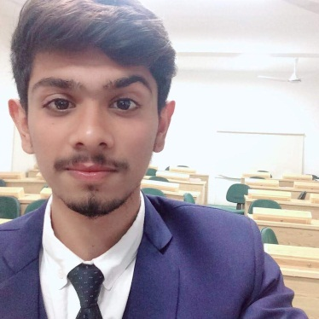

**RESUME**



**KHAWAJA MUHAMMAD SHOAIB WANI**

Contact No: +92-3312623842

**Email:** shoaib.wani04@gmail.com

**Address: H.no 46/LD PIA TOWNSHIP KARACHI**

### Objective

To be a part of competitive organization where I could apply my best professional skills, as an innovative person and to improve my learning capabilities both as team worker and leader through hard work and dedication. I offer my enthusiasm and dynamism with the following:

##### Qualification

**Academic Qualification**

* BSCS in progress from IQRA University Karachi.
* Intermediate from Karachi Board in the year.
* Matric from Karachi Board in year.

##### Personal Information

* Father Name : KHAWAJA ABDUL RAHIM
* Date of birth : 4thNov, 1998
* CNIC No : 42201-2944976-5
* Nationality : Pakistani

**Certifications**

* Domino English language center Karachi INTERMIDIATE LEVEL with Agrade

##### Computer Skills

* HTML5
* CSS3
* BOOTSTRAP
* Computer Languages (C, C++ Programing Languages,JAVA(oop))

##### Languages

* English
* Urdu

###### Reference

* Reference Would Be Provided On Your Request.